**Module 3 - PL/SQL Programming**

**Exercise 1: Control Structures**

**Scenario 1:** The bank wants to apply a discount to loan interest rates for customers above 60 years old.

**Question:** Write a PL/SQL block that loops through all customers, checks their age, and if they are above 60, apply a 1% discount to their current loan interest rates.

**OUERY:**

BEGIN

FOR rec IN (

SELECT c.CustomerID, c.Name, c.DOB, l.LoanID, l.InterestRate

FROM Customers c

JOIN Loans l ON c.CustomerID = l.CustomerID

WHERE MONTHS_BETWEEN(SYSDATE, c.DOB)/12 > 60

) LOOP

UPDATE Loans

SET InterestRate = InterestRate - 1

WHERE LoanID = rec.LoanID;

DBMS_OUTPUT.PUT_LINE('Discount aaplied to Loan ID: ' || rec.LoanID || ' of Customer: ' || rec.Name);

END LOOP;

END;

/

**OUTPUT:**

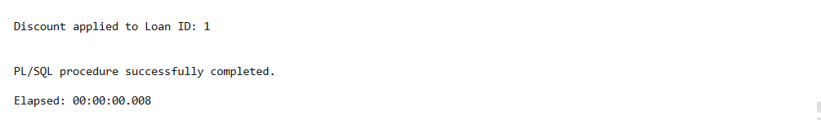

**Scenario 2:** A customer can be promoted to VIP status based on their balance.

**Question:** Write a PL/SQL block that iterates through all customers and sets a flag IsVIP to TRUE for those with a balance over $10,000.

**ALTER TABLE Customers ADD IsVIP VARCHAR2(5);**

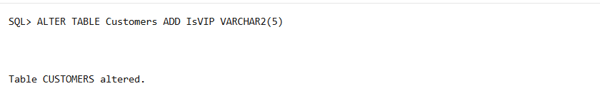

**UPDATE Customers SET IsVIP = 'FALSE';**

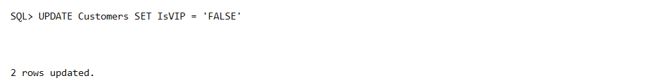

COMMIT;

**QUERY:**

BEGIN

FOR rec IN (

SELECT CustomerID, Balance

FROM Customers

WHERE Balance > 10000

) LOOP

UPDATE Customers

SET IsVIP = 'TRUE'

WHERE CustomerID = rec.CustomerID;

DBMS_OUTPUT.PUT_LINE('Customer ID ' || rec.CustomerID || ' promoted to VIP.');

END LOOP;

END;

/

**OUTPUT:**

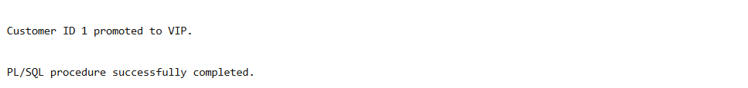

**Scenario 3:** The bank wants to send reminders to customers whose loans are due within the next 30 days.

**Question:** Write a PL/SQL block that fetches all loans due in the next 30 days and prints a reminder message for each customer.

**OUERY:**

BEGIN

  FOR rec IN (

    SELECT l.LoanID, l.CustomerID, c.Name, l.EndDate

    FROM Loans l

    JOIN Customers c ON l.CustomerID = c.CustomerID

    WHERE l.EndDate <= SYSDATE + 30

  ) LOOP

    DBMS_OUTPUT.PUT_LINE('Reminder: Dear ' || rec.Name ||

                         ', your Loan ID ' || rec.LoanID ||

                         ' is due on ' || TO_CHAR(rec.EndDate, 'DD-MON-YYYY') ||

                         '. Please make the necessary arrangements.');

  END LOOP;

END;

/

**OUTPUT:**

